**Coding Challenges: PetPals, The Pet Adoption Platform**

1.Create and implement the mentioned class and the structure in your application.

**Pet Class:**

Attribute:

• Name (string): The name of the pet.

• Age (int): The age of the pet.

• Breed (string): The breed of the pet. Methods:

• Constructor to initialize Name, Age, and Breed.

• Getters and setters for attributes.

• ToString() method to provide a string representation of the pet.

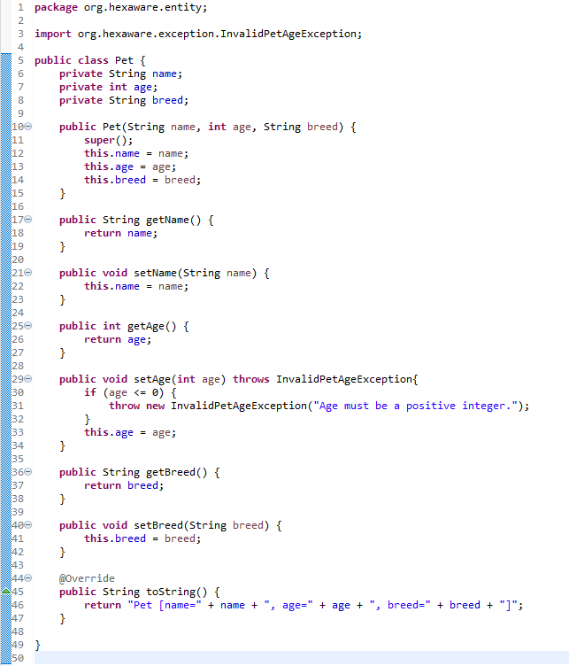

**Dog Class (Inherits from Pet):**

**Additional Attributes:**

• DogBreed (string): The specific breed of the dog.

**Additional Methods:**

• Constructor to initialize DogBreed.

• Getters and setters for DogBreed.

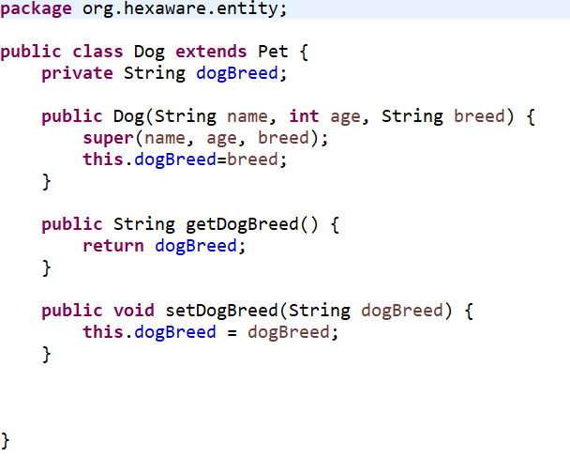

**Cat Class (Inherits from Pet):**

**Additional Attributes:**

• CatColor (string): The color of the cat.

**Additional Methods:**

• Constructor to initialize CatColor.

• Getters and setters for CatColor.

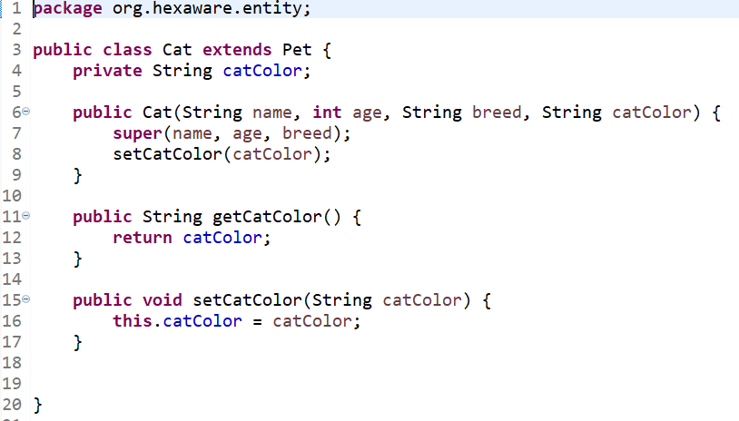

**3.PetShelter Class:**

**Attributes:**

• availablePets (List of Pet): A list to store available pets for adoption.

**Methods:**

• AddPet(Pet pet): Adds a pet to the list of available pets.

• RemovePet(Pet pet): Removes a pet from the list of available pets.

• ListAvailablePets(): Lists all available pets in the shelter.

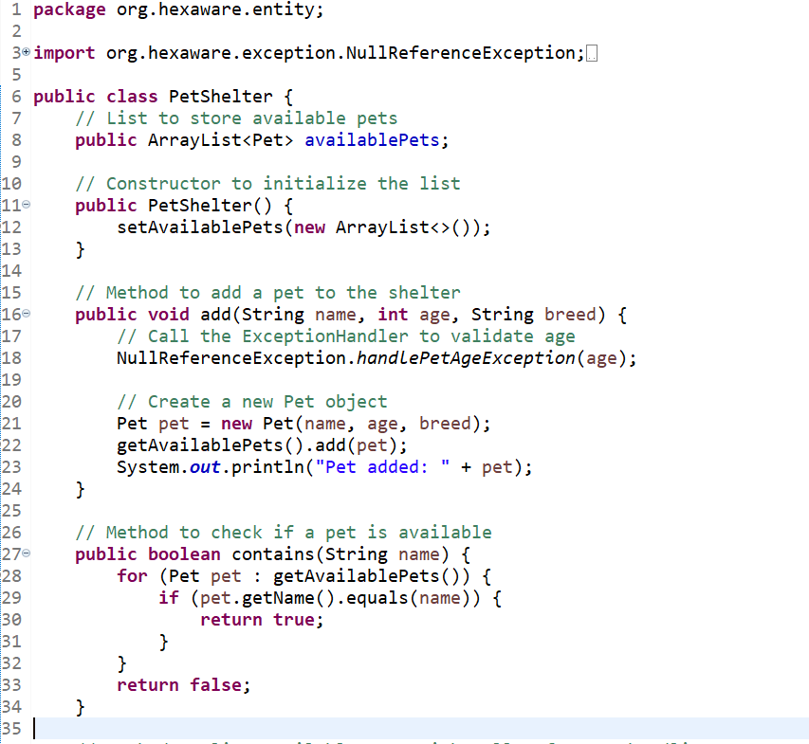

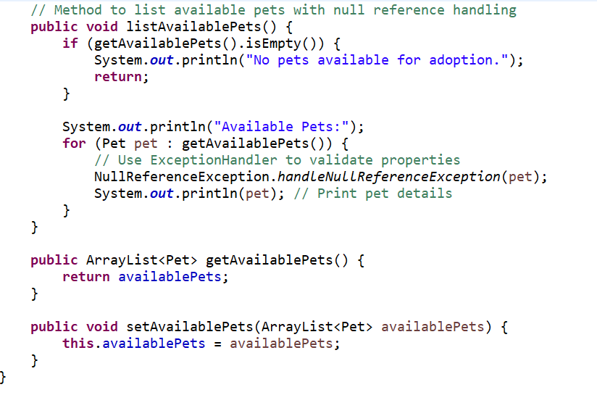

**4.Donation Class (Abstract):**

**Attributes:**

• DonorName (string): The name of the donor.

• Amount (decimal): The donation amount.

**Methods:**

• Constructor to initialize DonorName and Amount.

• Abstract method RecordDonation() to record the donation (to be implemented in derived classes).

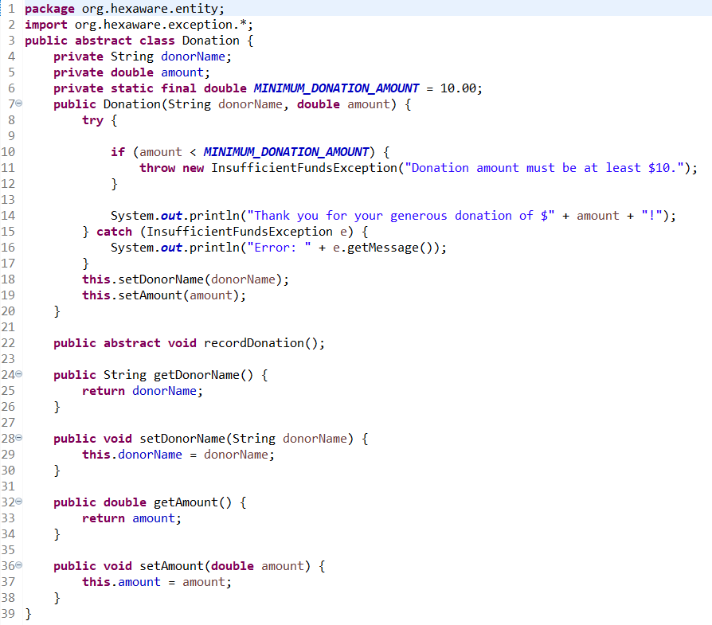

**CashDonation Class (Derived from Donation):**

**Additional Attributes:**

• DonationDate (DateTime): The date of the cash donation.

**Additional Methods:**

• Constructor to initialize DonationDate.

• Implementation of RecordDonation() to record a cash donation.

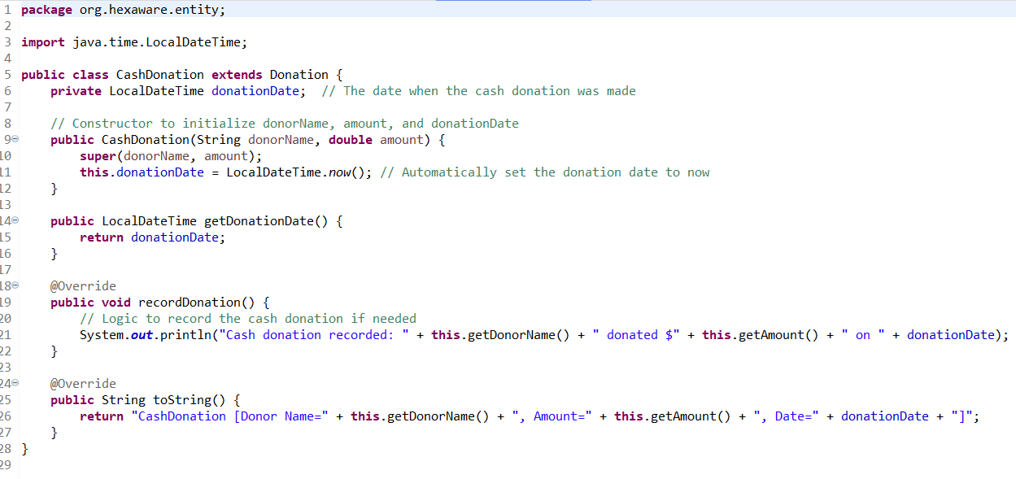

**ItemDonation Class (Derived from Donation):**

**Additional Attributes:**

• ItemType (string): The type of item donated (e.g., food, toys).

**Additional Methods:**

• Constructor to initialize ItemType.

• Implementation of RecordDonation() to record an item donation.

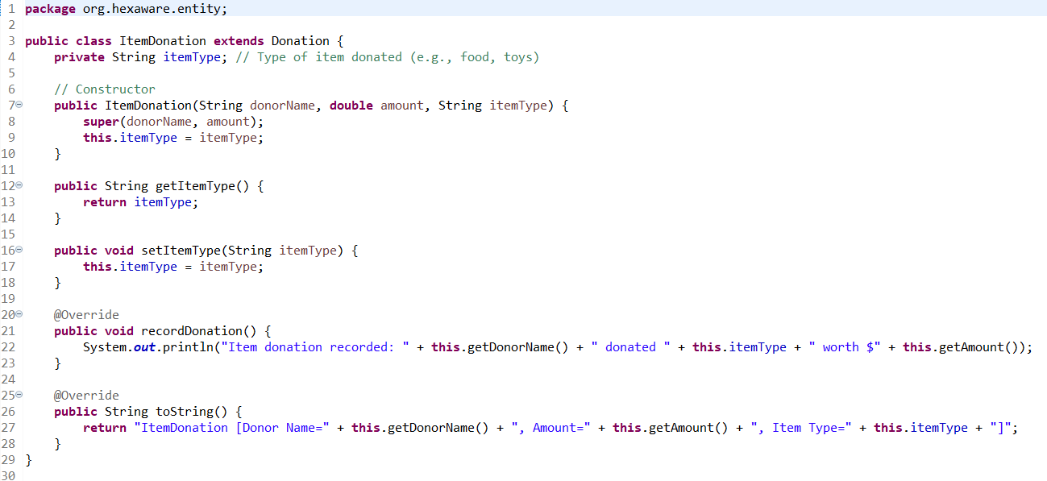

**5.IAdoptable Interface/Abstract Class:**

**Methods:**

• Adopt(): An abstract method to handle the adoption process.

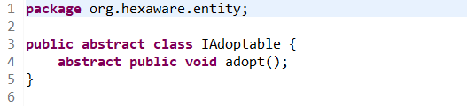

**AdoptionEvent Class:**

**Attributes:**

• Participants (List of IAdoptable): A list of participants (shelters and adopters) in the adoption event.

**Methods:**

• HostEvent(): Hosts the adoption event.

• RegisterParticipant(IAdoptable participant): Registers a participant for the event.

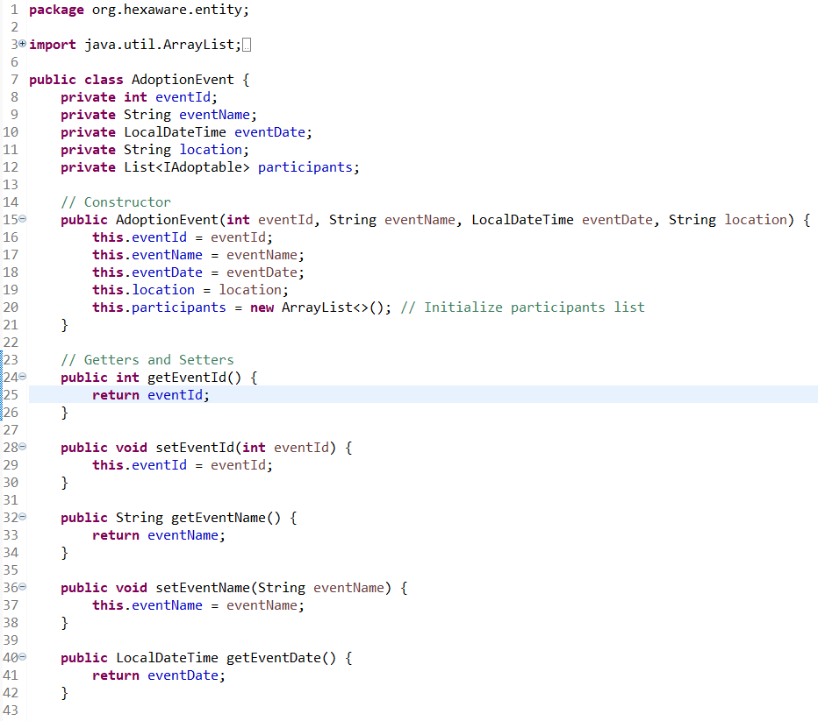

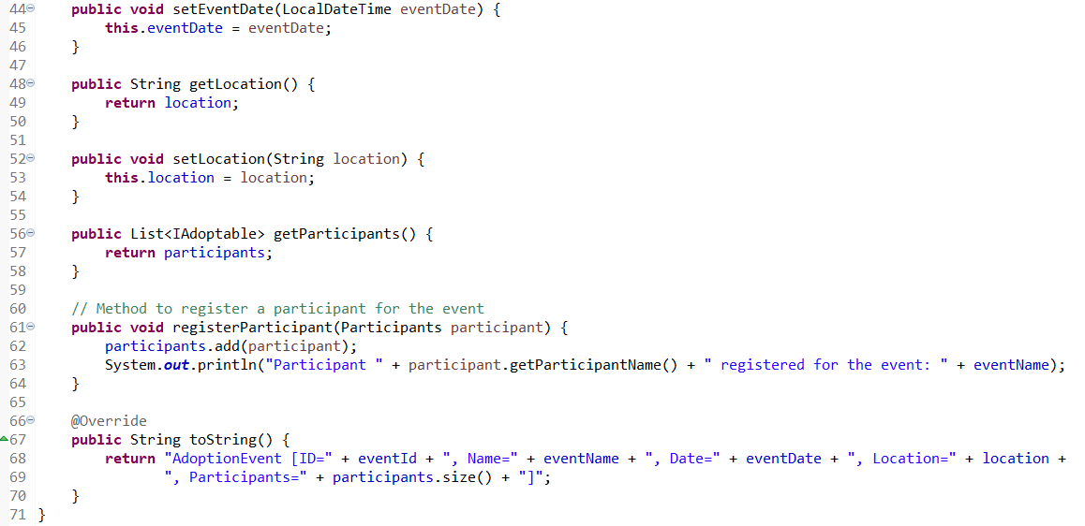



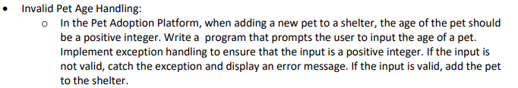

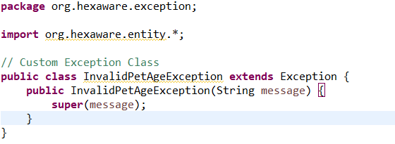

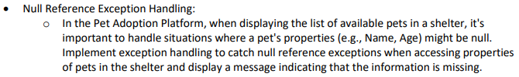

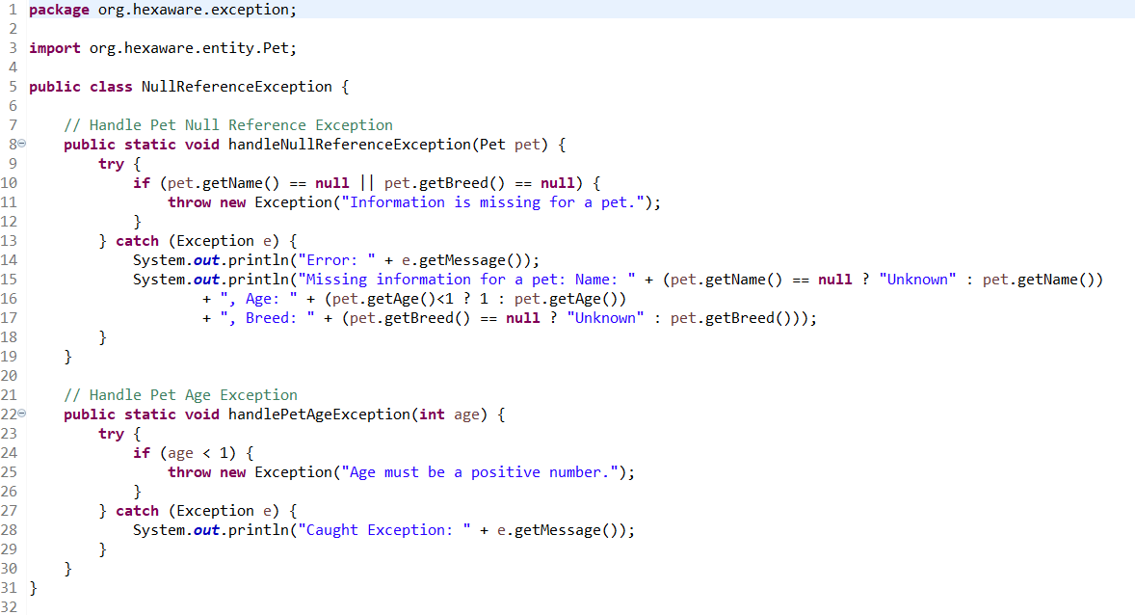

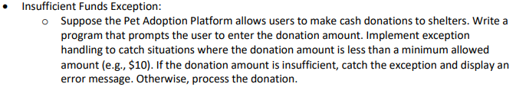

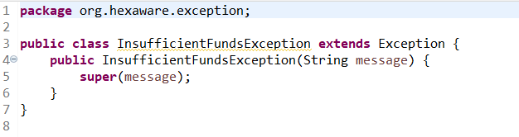

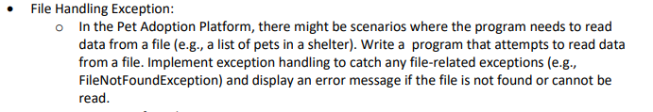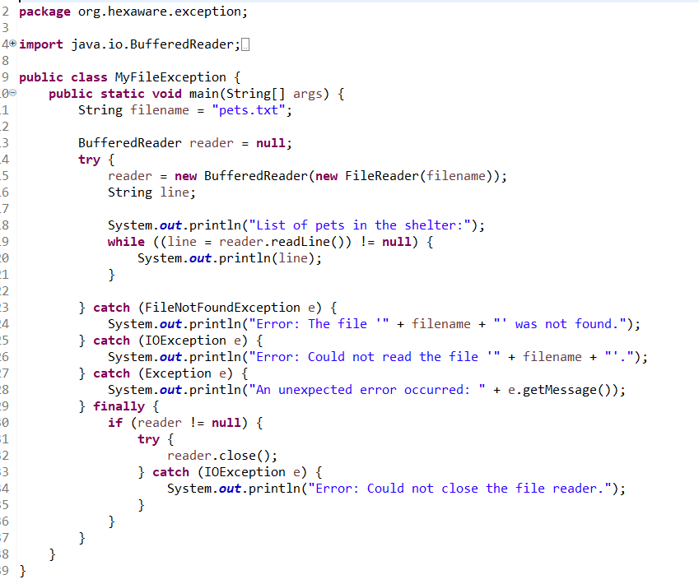

* **Custom Exception For Adoption Errors:**

o Design a custom exception class called AdoptionException that inherits from Exception. In the Pet Adoption Platform, use this custom exception to handle adoption-related errors, such as attempting to adopt a pet that is not available or adopting a pet with missing information. Create instances of AdoptionException with different error messages and catch them appropriately in your program.

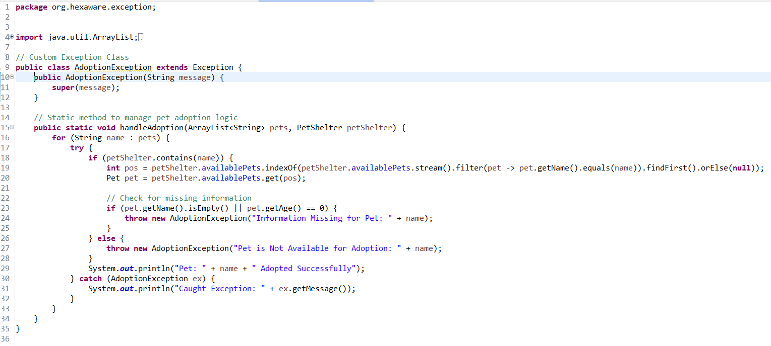

**7.Database Connectivity Create and implement the following tasks in your application.**

• **Displaying Pet Listings:**

o Develop a program that connects to the database and retrieves a list of available pets from the "pets" table. Display this list to the user. Ensure that the program handles database connectivity exceptions gracefully, including cases where the database is unreachable.

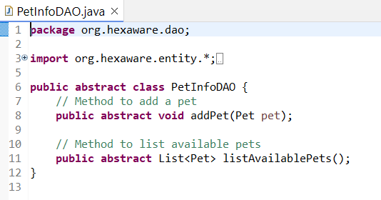

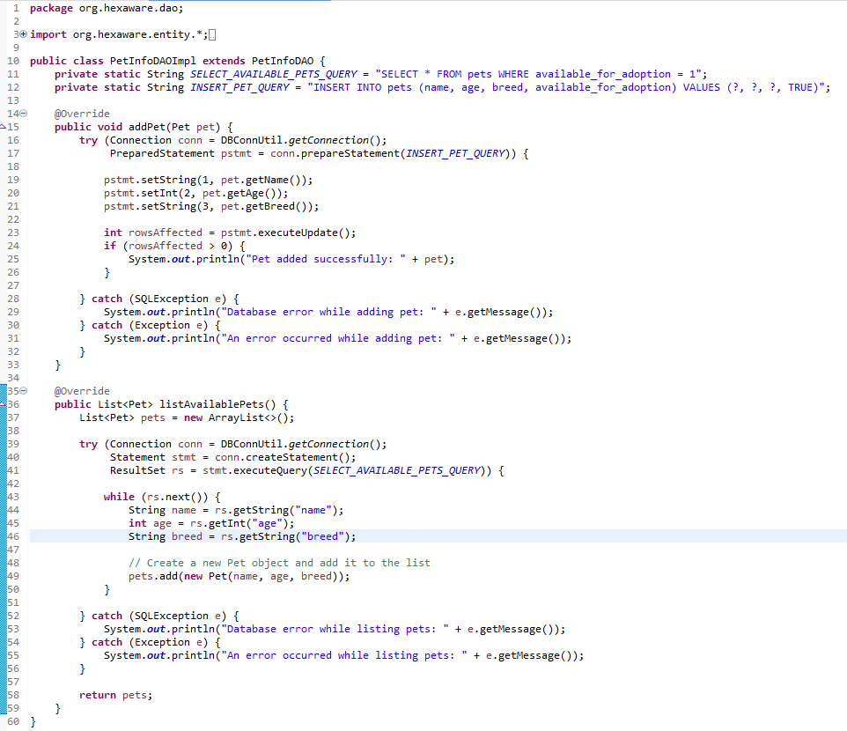

**• Donation Recording:**

o Create a program that records cash donations made by donors. Allow the user to input donor information and the donation amount and insert this data into the "donations" table in the database. Handle exceptions related to database operations, such as database errors or invalid inputs.

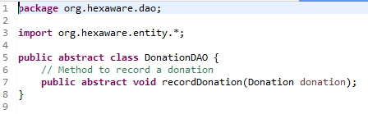

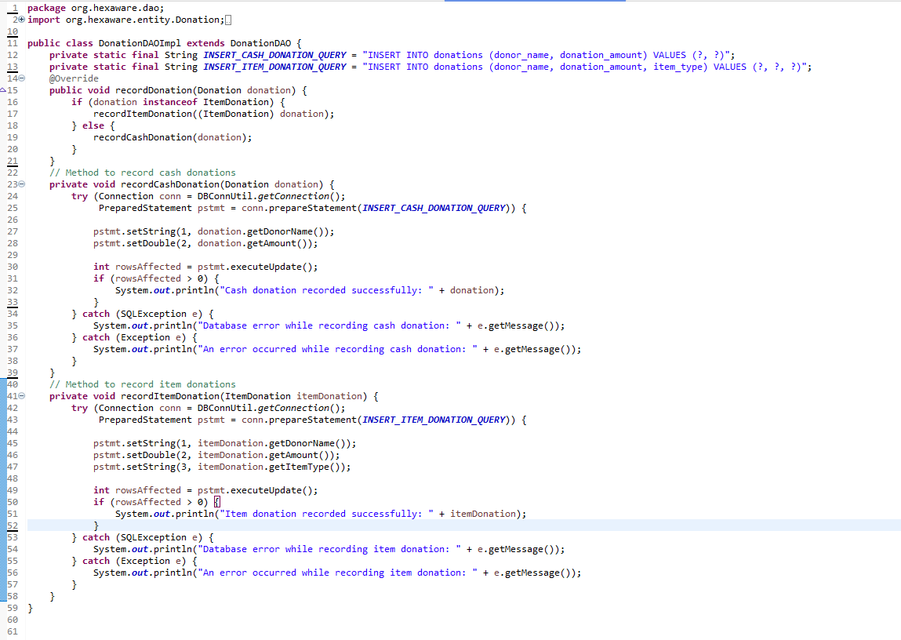

**• Adoption Event Management:**

o Build a program that connects to the database and retrieves information about upcoming adoption events from the "adoption_events" table. Allow the user to register for an event by adding their details to the "participants" table. Ensure that the program handles database connectivity and insertion exceptions properly.

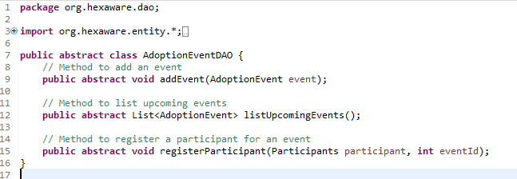

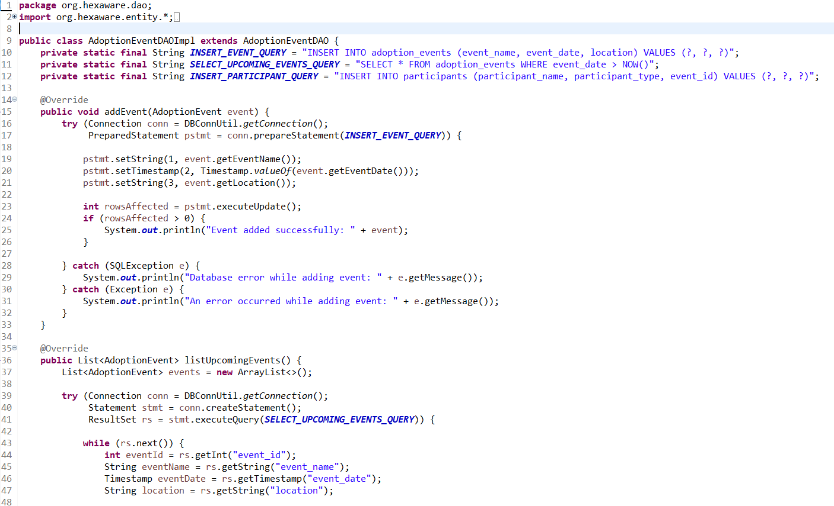

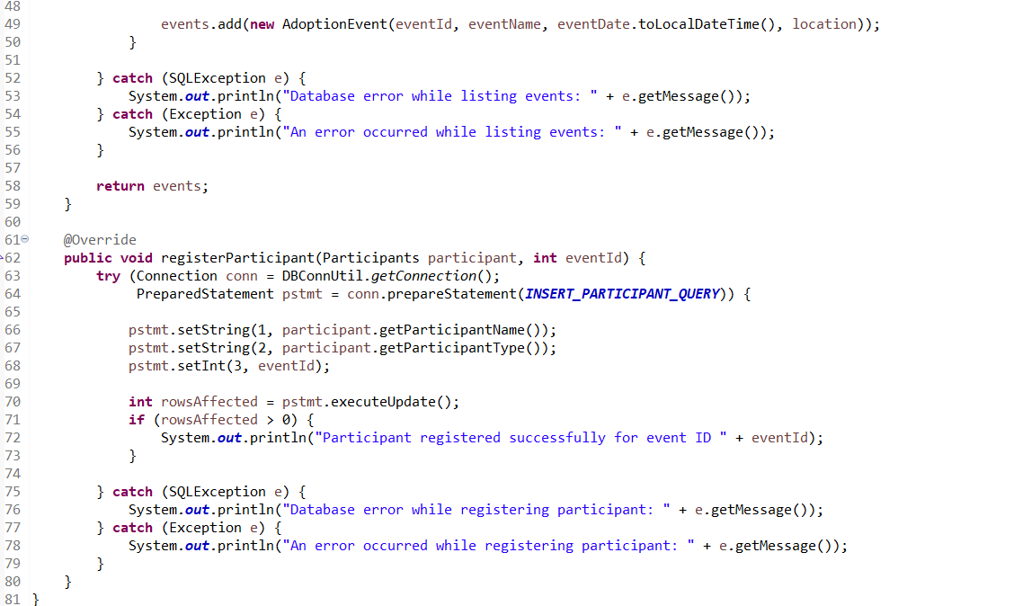

**o Main**

▪ Create a class MainModule and demonstrate the functionalities in a menu driven application.

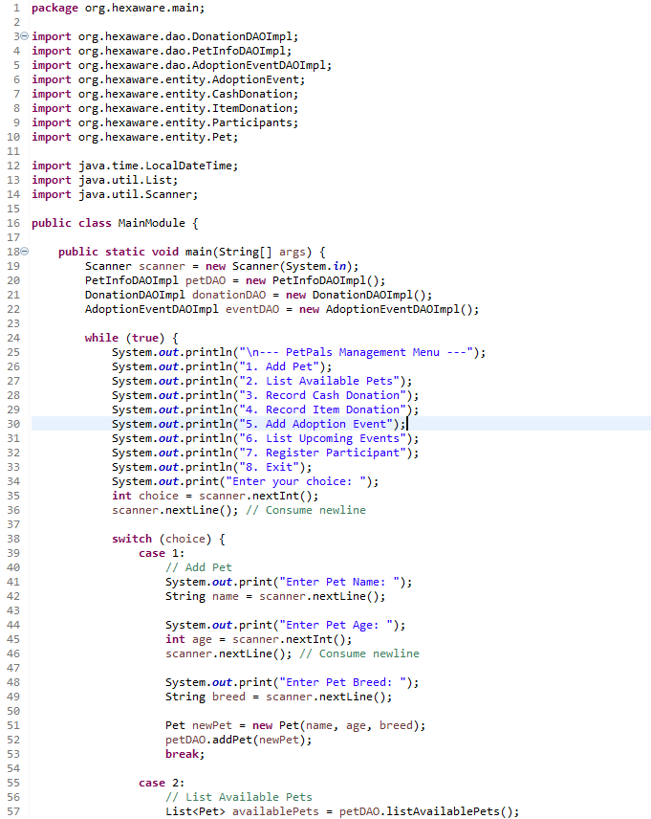

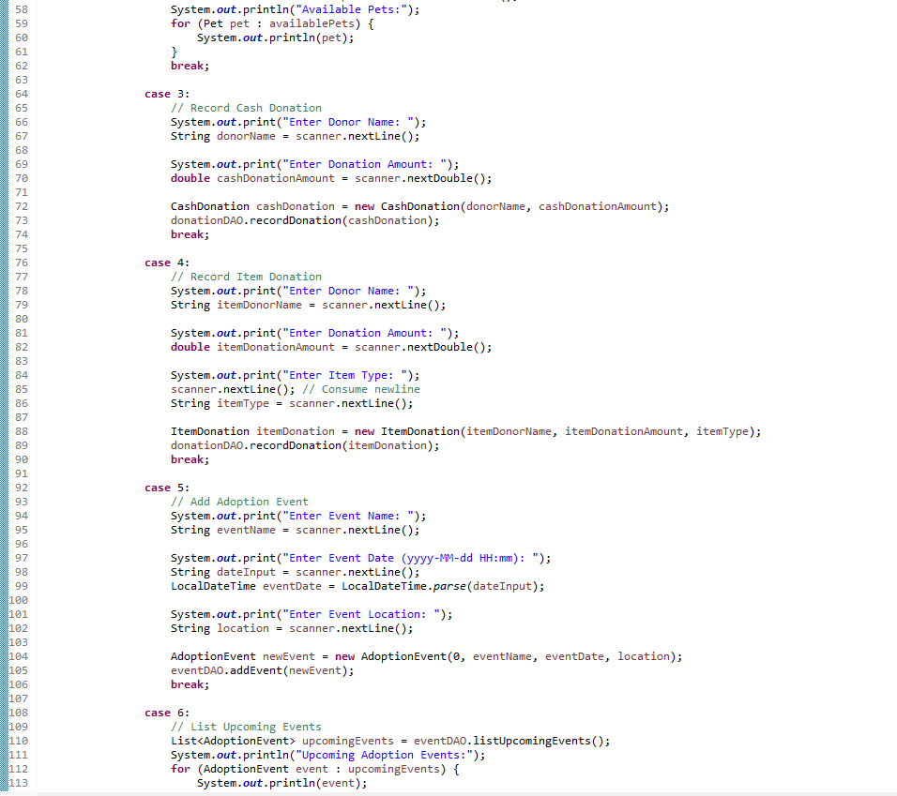

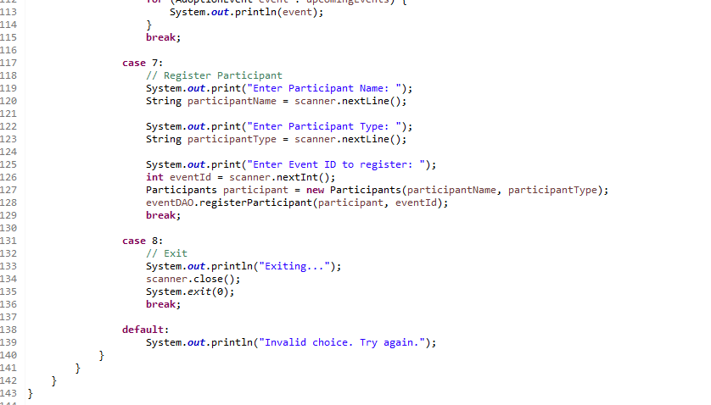

**OUTPUT:**

--- PetPals Management Menu ---

1. Add Pet

2. List Available Pets

3. Record Cash Donation

4. Record Item Donation

5. Add Adoption Event

6. List Upcoming Events

7. Register Participant

8. Exit

Enter your choice: 1

Enter Pet Name: Maxxien

Enter Pet Age: 3

Enter Pet Breed: Labrador

Pet added successfully: Pet [name=Maxxien, age=3, breed=Labrador]

--- PetPals Management Menu ---

1. Add Pet

2. List Available Pets

3. Record Cash Donation

4. Record Item Donation

5. Add Adoption Event

6. List Upcoming Events

7. Register Participant

8. Exit

Enter your choice: 2

Available Pets:

Pet [name=Max, age=3, breed=Labrador]

Pet [name=Bella, age=2, breed=Poodle]

Pet [name=Daisy, age=1, breed=Bulldog]

Pet [name=Molly, age=3, breed=Siamese]

Pet [name=Buddy, age=2, breed=Golden Retriever]

Pet [name=Coco, age=6, breed=Maltese]

Pet [name=Luna, age=1, breed=Dachshund]

Pet [name=Max, age=3, breed=Labrador]

Pet [name=Maxxien, age=3, breed=Labrador]

--- PetPals Management Menu ---

1. Add Pet

2. List Available Pets

3. Record Cash Donation

4. Record Item Donation

5. Add Adoption Event

6. List Upcoming Events

7. Register Participant

8. Exit

Enter your choice: 3

Enter Donor Name: Santhosh Kosuru

Enter Donation Amount: 2000

Thank you for your generous donation of $2000.0!

Cash donation recorded successfully: CashDonation [Donor Name=Santhosh Kosuru, Amount=2000.0, Date=2024-10-05T14:54:42.605942900]

--- PetPals Management Menu ---

1. Add Pet

2. List Available Pets

3. Record Cash Donation

4. Record Item Donation

5. Add Adoption Event

6. List Upcoming Events

7. Register Participant

8. Exit

Enter your choice: 4

Enter Donor Name: Santhosh Kumar

Enter Donation Amount: 10.00

Enter Item Type: Blanket

Thank you for your generous donation of $10.0!

Item donation recorded successfully: ItemDonation [Donor Name=Santhosh Kumar, Amount=10.0, Item Type=Blanket]

--- PetPals Management Menu ---

1. Add Pet

2. List Available Pets

3. Record Cash Donation

4. Record Item Donation

5. Add Adoption Event

6. List Upcoming Events

7. Register Participant

8. Exit

Enter your choice: 5

Enter Event Name: Cats & Dogs

Enter Event Date (yyyy-MM-dd HH:mm): 2024-10-05T14:54:42.605942900

Enter Event Location: Visakhapatnam

Event added successfully: AdoptionEvent [ID=0, Name=Cats & Dogs, Date=2024-10-05T14:54:42.605942900, Location=Visakhapatnam, Participants=0]

--- PetPals Management Menu ---

1. Add Pet

2. List Available Pets

3. Record Cash Donation

4. Record Item Donation

5. Add Adoption Event

6. List Upcoming Events

7. Register Participant

8. Exit

Enter your choice: 6

Upcoming Adoption Events:

AdoptionEvent [ID=1, Name=Adoption Day, Date=2024-10-12T10:00, Location=Community Center, NY, Participants=0]

AdoptionEvent [ID=2, Name=Furry Friends Day, Date=2024-10-15T11:00, Location=Pet Haven, IL, Participants=0]

AdoptionEvent [ID=3, Name=Paws for a Cause, Date=2024-10-20T12:00, Location=Wagging Tails Shelter, PA, Participants=0]

AdoptionEvent [ID=4, Name=Second Chances, Date=2024-10-22T09:00, Location=Happy Paws Shelter, NY, Participants=0]

AdoptionEvent [ID=5, Name=Pet Fiesta, Date=2024-10-30T13:00, Location=Caring Hearts Rescue, CA, Participants=0]

AdoptionEvent [ID=6, Name=Lucky Pets Day, Date=2024-11-05T14:00, Location=Hope Animal Shelter, TX, Participants=0]

AdoptionEvent [ID=7, Name=Canine Carnival, Date=2024-11-10T10:00, Location=Forever Home Shelter, CA, Participants=0]

AdoptionEvent [ID=8, Name=Kittens and Coffee, Date=2024-11-12T11:00, Location=Pet Haven, IL, Participants=0]

AdoptionEvent [ID=9, Name=Adoption Fair, Date=2024-11-15T12:00, Location=Pawtastic Shelter, TX, Participants=0]

AdoptionEvent [ID=10, Name=Rescue Rally, Date=2024-11-20T09:00, Location=Furry Friends Rescue, AZ, Participants=0]

--- PetPals Management Menu ---

1. Add Pet

2. List Available Pets

3. Record Cash Donation

4. Record Item Donation

5. Add Adoption Event

6. List Upcoming Events

7. Register Participant

8. Exit

Enter your choice: 7

Enter Participant Name: Sanjay

Enter Participant Type: Adopter

Enter Event ID to register: 2

Participant registered successfully for event ID 2

--- PetPals Management Menu ---

1. Add Pet

2. List Available Pets

3. Record Cash Donation

4. Record Item Donation

5. Add Adoption Event

6. List Upcoming Events

7. Register Participant

8. Exit

Enter your choice: 8

Exiting...